

K.R. Mangalam University
School of Engineering & Technology

Lab Assignment-(3)

Analysis and Design of Algorithms (ADA)

Implementation and Analysis of Graph Algorithms including Traversal,
Topological Sorting, Shortest Path, and Minimum Spanning Tree

Submitted by: Submitted to:
NAME: ARYAVEER SINGH Dr. Aarti
ROLL NO: 2401010273
PROGRAM: B. TECH -CSE CORE
SECTION – C

ADA LAB (Assignment-3)

Task 1: Graph Representation

Deliverables
- Graph and matrix representation

Code-
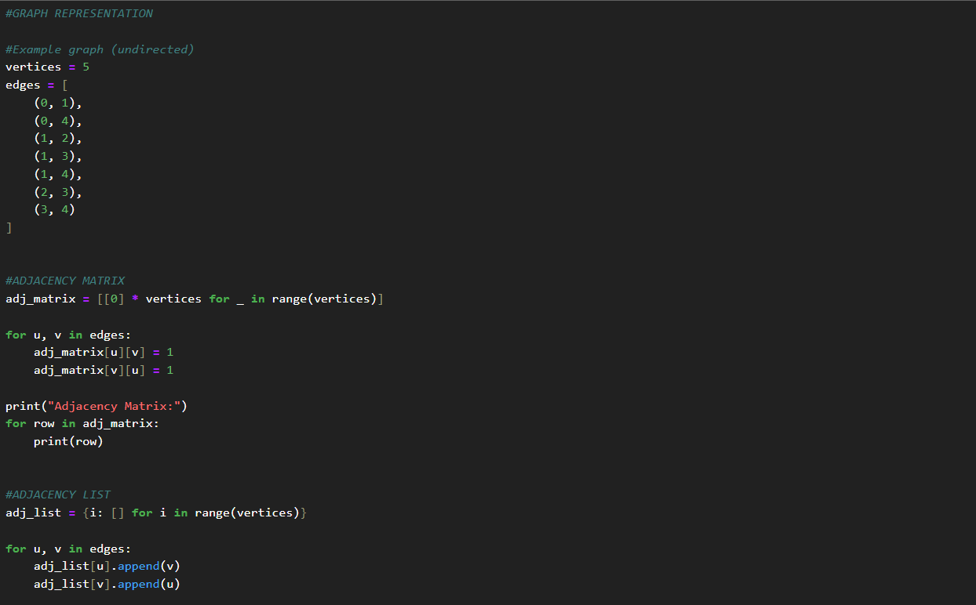

Output-
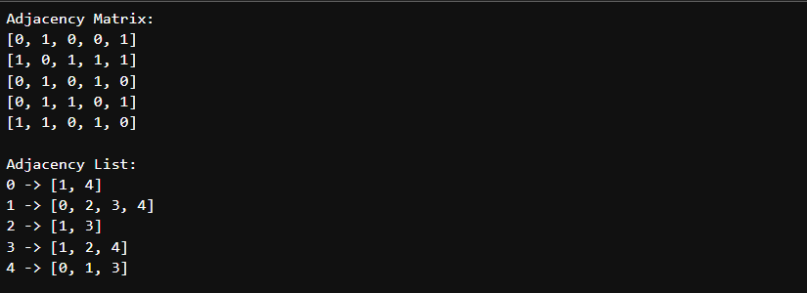
Task 2: Graph Traversal Algorithms

Deliverables
- BFS and DFS implementations

Code-
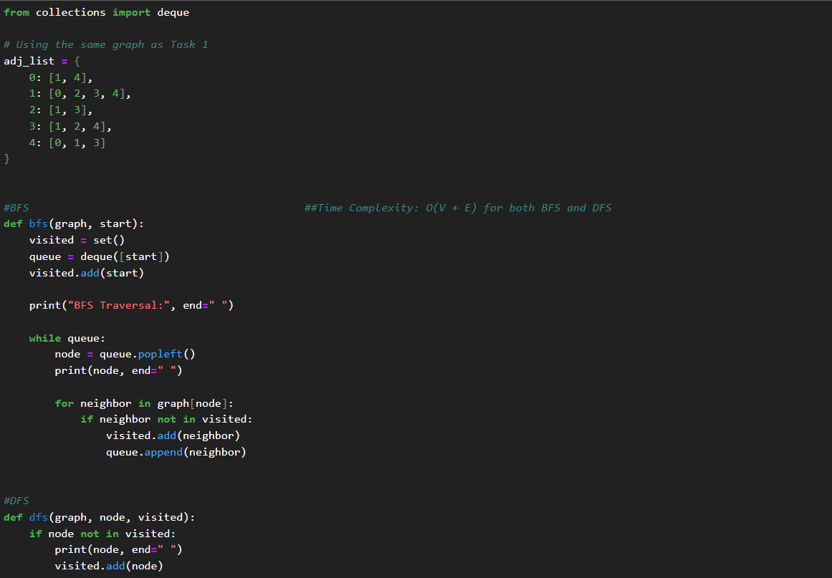
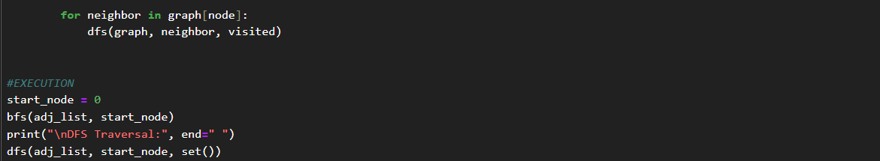

Output-

Task 3: Topological Sorting

Deliverables
- Topological sort implementation

Code-
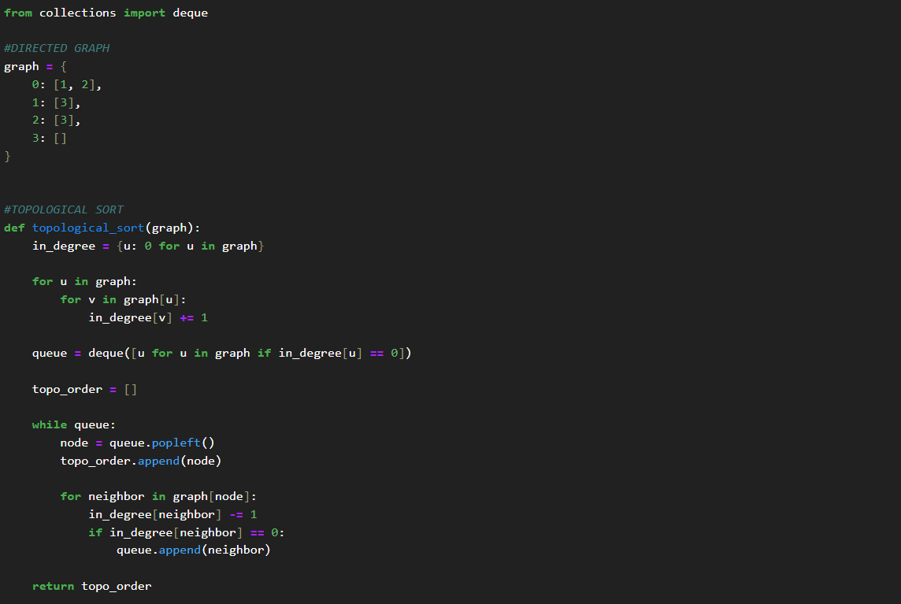

Output-

Task 4: Shortest Path Algorithms

Deliverables
- Represent graph using adjacency list/matrix as appropriate
- Display shortest path distances
- Compare time complexity behaviors for small graphs

Code-
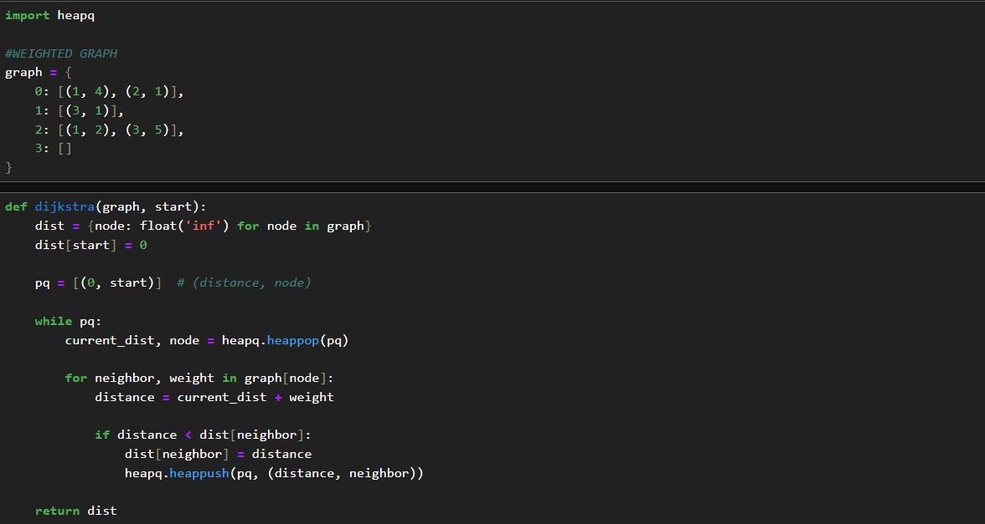
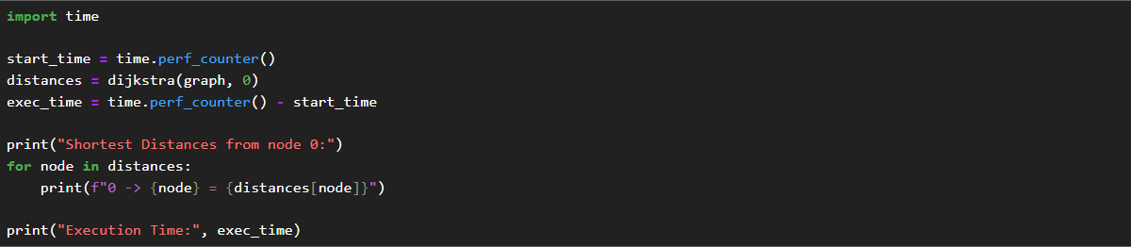
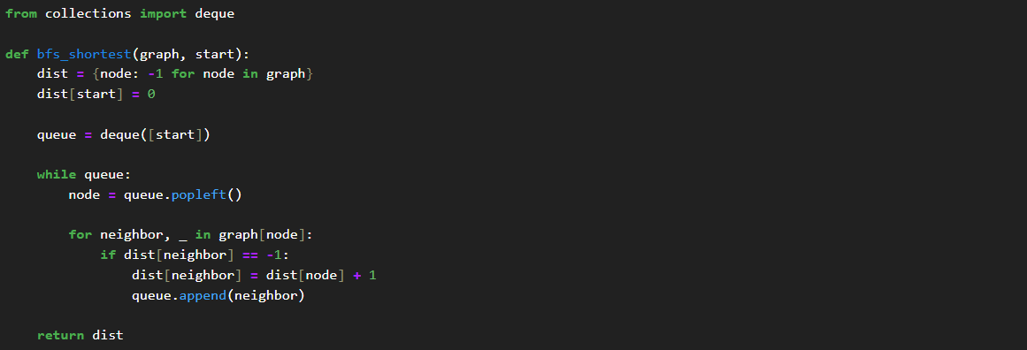
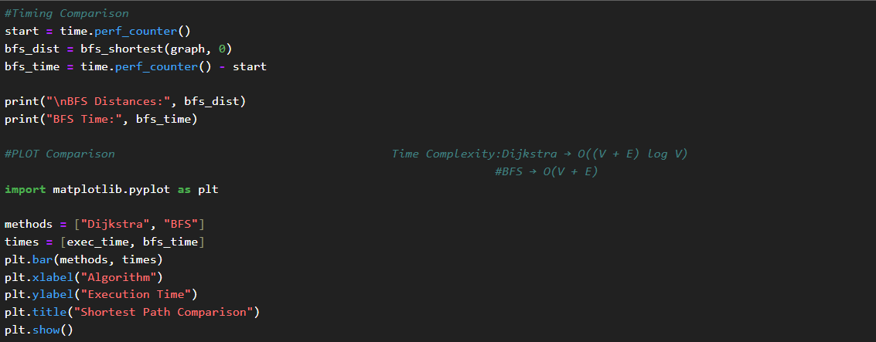

Output-
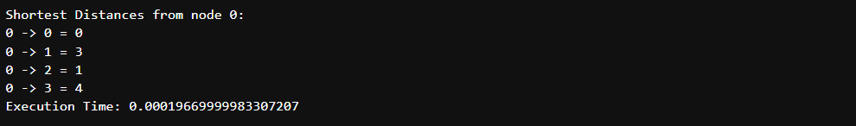

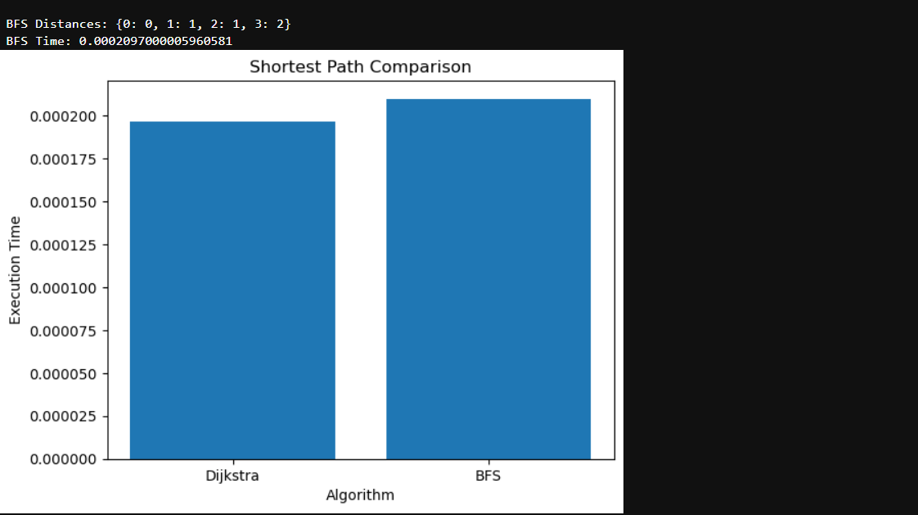

Task 5: Minimum Spanning Tree Algorithms

Deliverables
- MST implementations
Code-
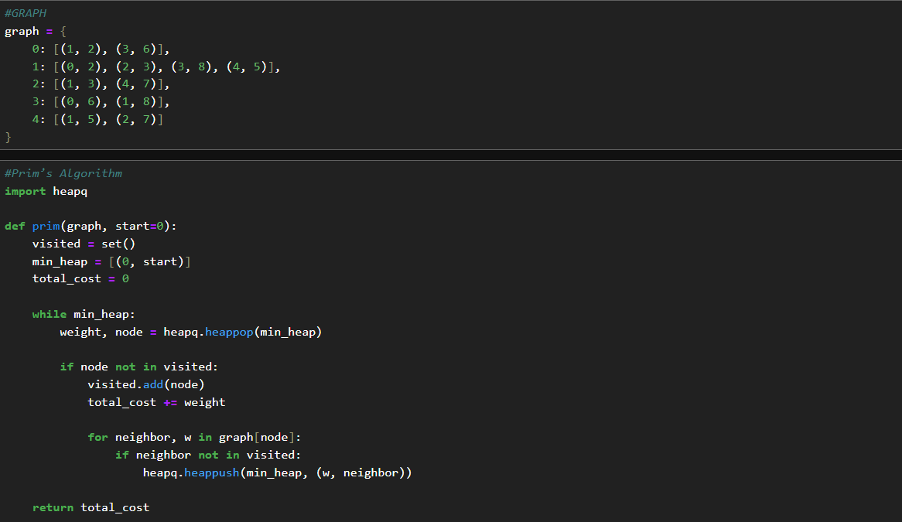

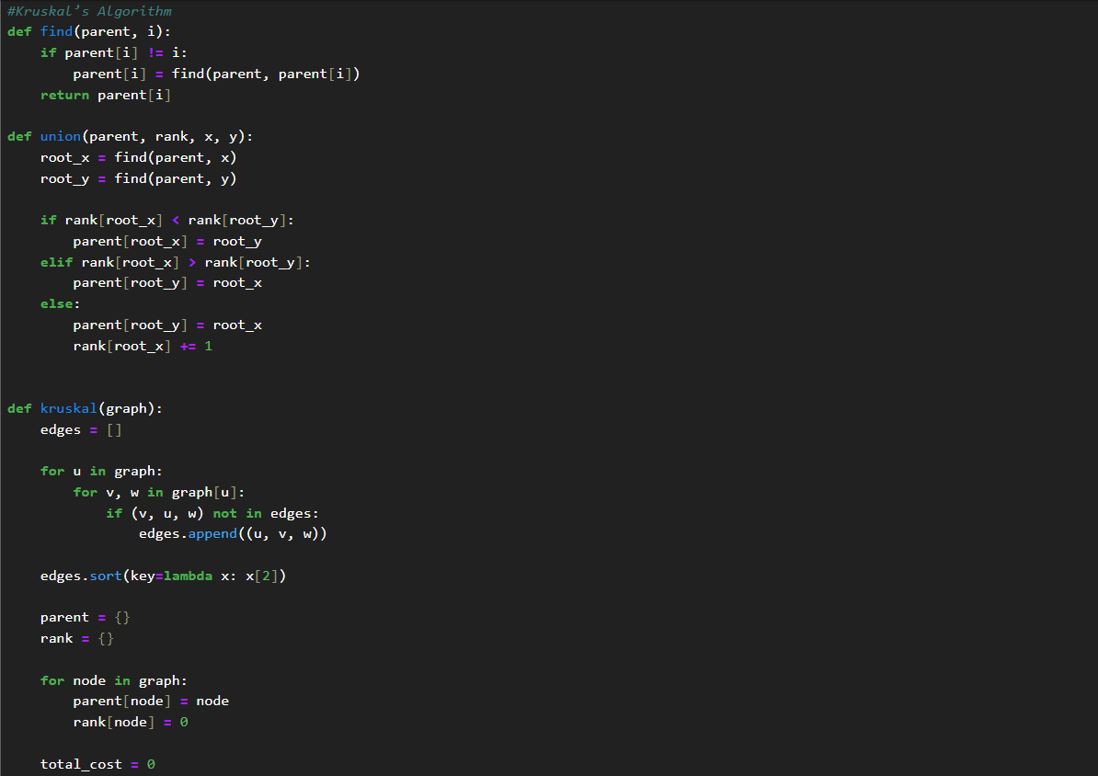
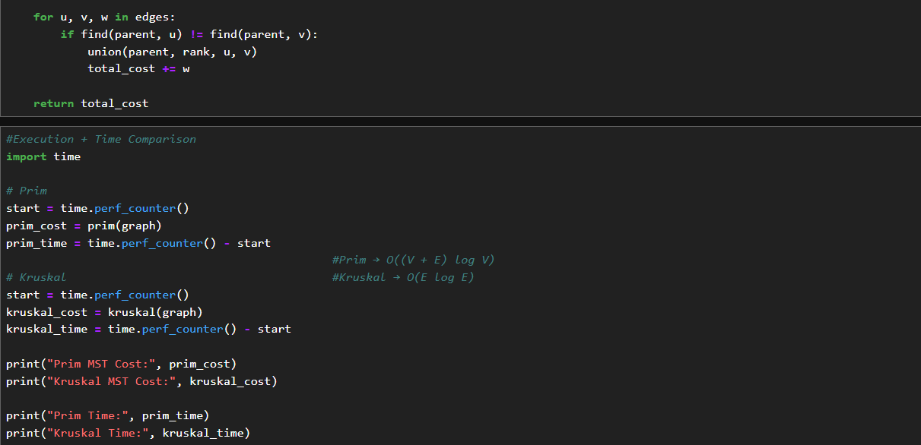

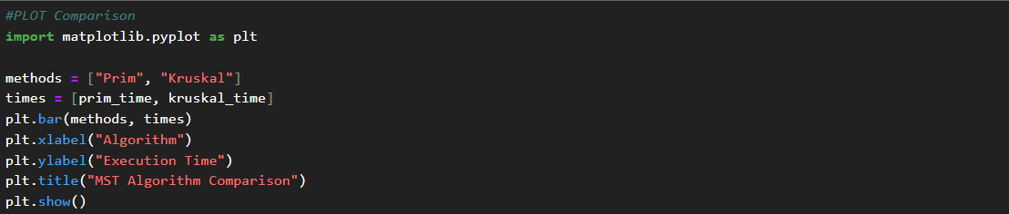

Output-
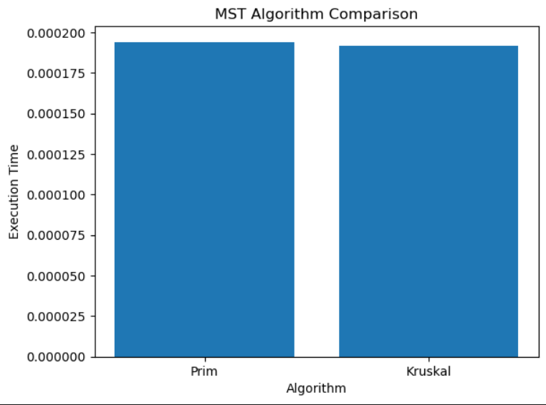
Reflection & Discussion

- Algorithm Suitability
Among all the graph algorithms, Dijkstra’s algorithm is highly suitable for real-world applications such as navigation systems and route planning. It efficiently computes the shortest path in weighted graphs where all edge weights are non-negative.

Similarly, BFS is useful for unweighted graphs like social networks to find the shortest connection between users, while DFS is useful for exploring graph structures and detecting cycles.

- Complexity vs. Scalability
BFS and DFS perform efficiently on both sparse and dense graphs with a time complexity of O (V + E). However, in dense graphs, the number of edges increases significantly, which can affect performance.

For shortest path algorithms, Dijkstra scales well for medium-sized graphs, but Bellman-Ford becomes slower for large graphs due to its higher time complexity O (V × E). Therefore, algorithm choice depends on graph size and edge characteristics.

- Infrastructure Impact
In Minimum Spanning Tree problems, the choice between Prim’s and Kruskal’s algorithms affects performance and implementation.

Prim’s algorithm is more efficient for dense graphs as it grows the tree by adding vertices, while Kruskal’s algorithm is better suited for sparse graphs since it processes edges in increasing order of weight.

The choice of algorithm can impact the total computation cost and efficiency in real-world applications such as network design and cable routing.

- Edge Case Handling
Negative weight cycles present a major challenge in shortest path problems, as they can lead to incorrect or infinite solutions.

Dijkstra’s algorithm cannot handle negative weights, while Bellman-Ford algorithm is specifically designed to detect and handle such cases. It checks for negative cycles and prevents incorrect path calculations, making it suitable for such scenarios.

- Extensibility
A real-world example of a graph problem is recommendation systems used in e-commerce platforms. These systems can be modeled as graphs where users and products are nodes, and edges represent interactions.

Algorithms such as BFS or shortest path algorithms can be used to suggest related products or connections. Graph-based machine learning techniques can further enhance such systems.

Conclusion

In this lab assignment, various graph algorithms including graph representation, traversal techniques (BFS and DFS), topological sorting, shortest path algorithms, and minimum spanning tree algorithms were implemented and analyzed.

The comparison of different algorithms provided a clear understanding of their efficiency, time complexity, and suitability for different types of problems. Dijkstra’s algorithm proved effective for weighted shortest path problems, while BFS and DFS demonstrated efficient graph traversal. Additionally, Prim’s and Kruskal’s algorithms highlighted different approaches to constructing minimum spanning trees.

Overall, this assignment helped in understanding the practical applications of graph algorithms and their importance in solving real-world problems such as network design, routing, and optimization.

GitHub Repository Link:
https://github.com/Aryaveersingh14

